ASSIGNMENT-5.1
NAME: L . Srinivas Reddy
H.T.NO:2303A52274
BATCH:36

Task Description #1 (Privacy in API Usage)
Task: Use an AI tool to generate a Python program that connects to a
weather API.
Prompt:
"Generate code to fetch weather data securely without exposing API keys
in the code."
Expected Output:
• Original AI code (check if keys are hardcoded).
• Secure version using environment variables.
CODE:
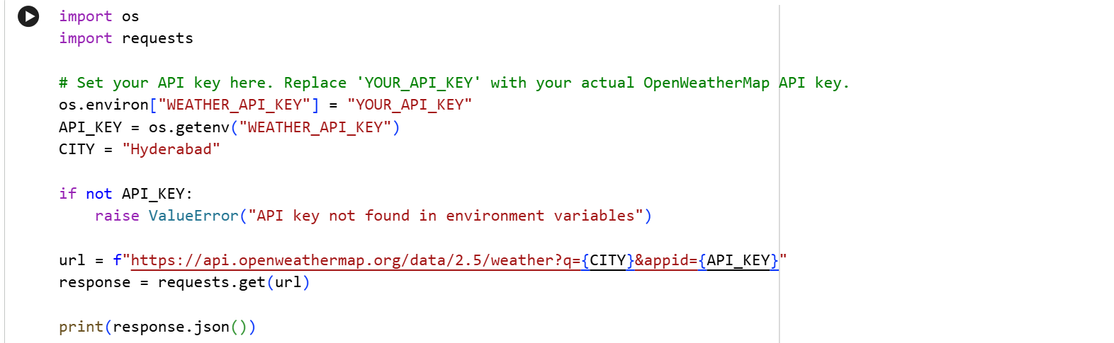
OUTPUT:
Task Description #2 (Privacy & Security in File Handling)
Task: Use an AI tool to generate a Python script that stores user data
(name, email, password) in a file.
Analyze: Check if the AI stores sensitive data in plain text or without
encryption.
Expected Output:
• Identified privacy risks.
• Revised version with encrypted password storage (e.g., hashing).
CODE:
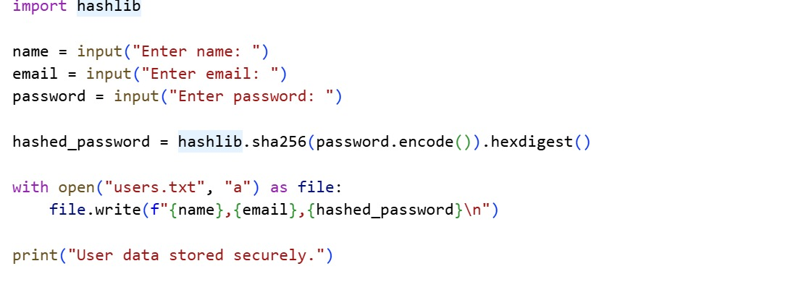
OUTPUT:
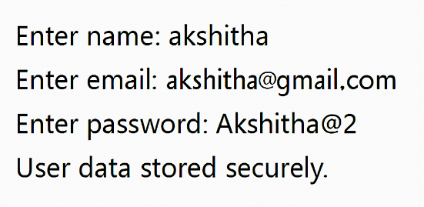
Task Description #3 (Transparency in Algorithm Design)
Objective: Use AI to generate an Armstrong number checking function
with comments and explanations.
Instructions:
1. Ask AI to explain the code line-by-line.
2. Compare the explanation with code functionality.
Expected Output:
• Transparent, commented code.
• Correct, easy-to-understand explanation.
CODE:
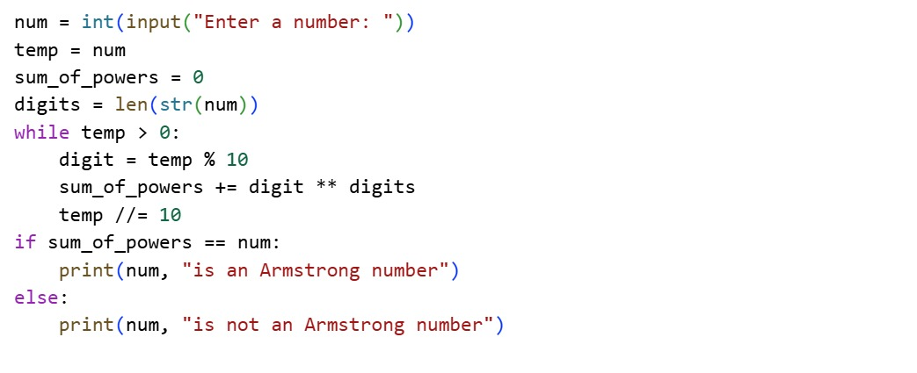
OUTPUT:
Task Description #4 (Transparency in Algorithm Comparison)
Task: Use AI to implement two sorting algorithms (e.g., QuickSort and
BubbleSort).
Prompt:
"Generate Python code for QuickSort and BubbleSort, and include
comments explaining step-by-step how each works and where they differ."
Expected Output:
• Code for both algorithms.
• Transparent, comparative explanation of their logic and efficiency.
CODE:
QUICK SORT:
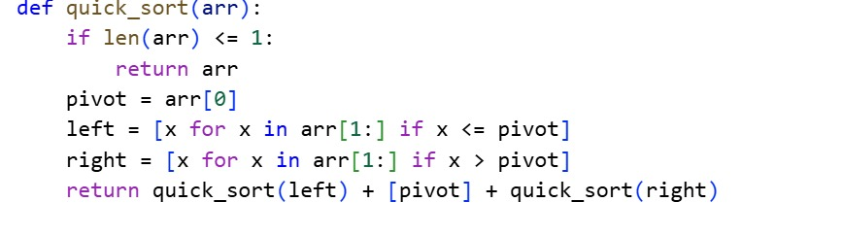
BUBBLE SORT:
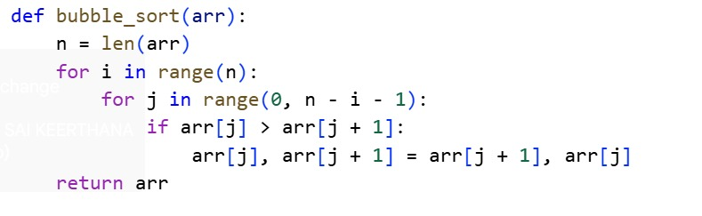
COMPARISON TABLE:
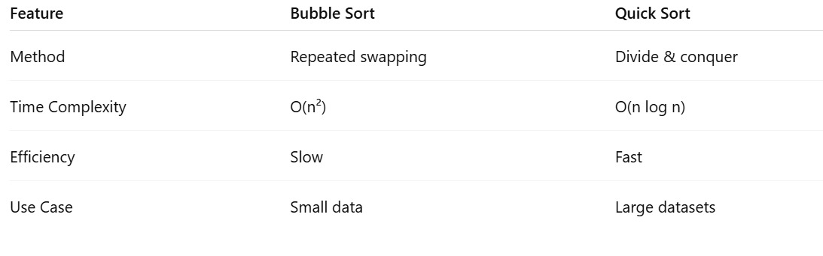
Task Description #5 (Transparency in AI Recommendations)
Task: Use AI to create a product recommendation system.
Prompt:
"Generate a recommendation system that also provides reasons for each
suggestion."
Expected Output:
• Code with explainable recommendations.
• Evaluation of whether explanations are understandable.
CODE:
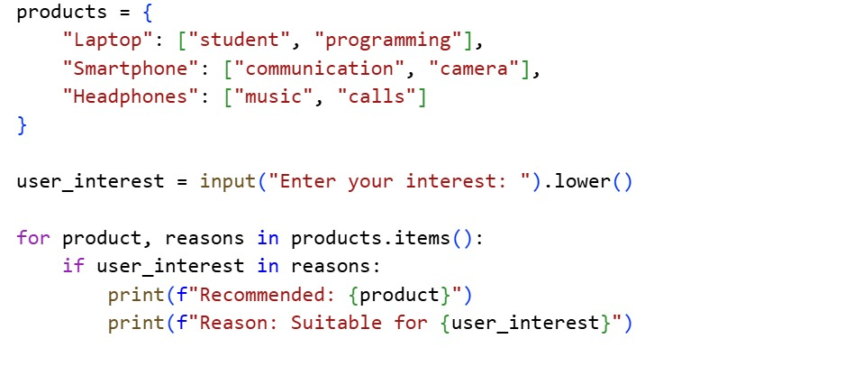
OUTPUT:


